Name:Paulson k babu

Splunk Practical Lab Documentation
Purpose:
This document is used to record hands-on work performed in Splunk, including screenshots, configurations, observations, and results.

1. Environment Details
Splunk Version:10.0.2
Splunk Type :Enterprise

2. Objective of the Task
1. Network Visibility and Baseline Establishment
By uploading the 100+ DNS events, the objective was to create a "baseline" of normal network activity. This allows an analyst to:
- Identify Traffic Patterns: Categorize traffic by query types (A, AAAA, CNAME) to understand what protocols are active on the network.
- Track Assets: Map internal IP addresses (src_ip) to the external domains they are visiting.

2. Security Threat Detection
The ultimate security objective was to use Search Processing Language (SPL) to proactively find signs of compromise, such as:
- Detecting Malware Communication: Searching for NXDOMAIN responses which often indicate Domain Generation Algorithms (DGA) used by ransomware or botnets.
- Spotting Data Exfiltration: Monitoring for unusual query volumes or "low and slow" DNS tunneling attempts.

3. Data Upload Details
File Name:dns_traffic.log
Index Used:dns_logs
Sourcetype:dnslog

4. Configuration Steps
Step-by-step actions performed in Splunk:
Step 1:
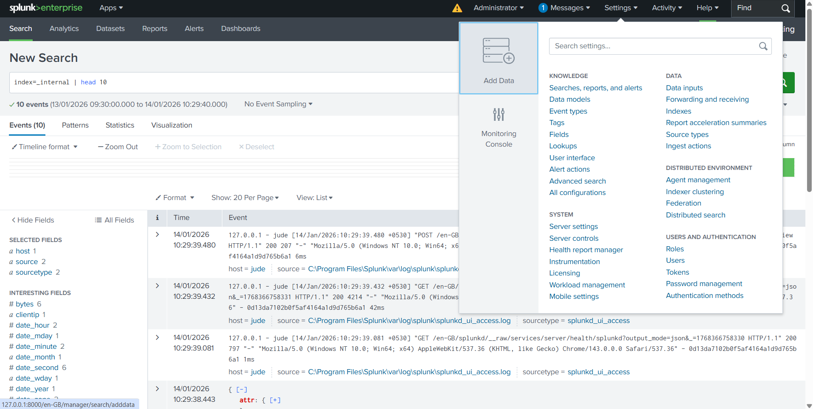
Step 2:
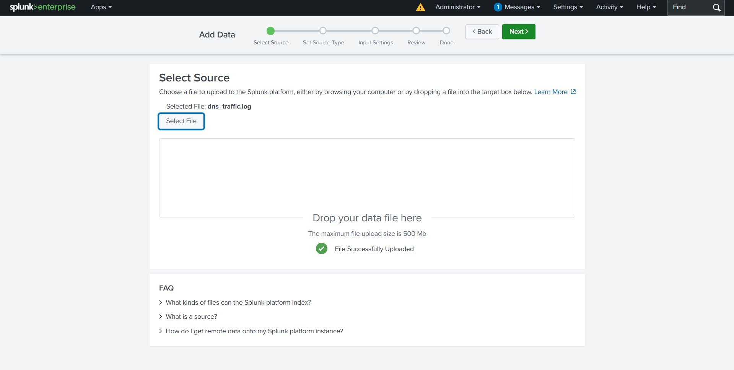
Step 3:

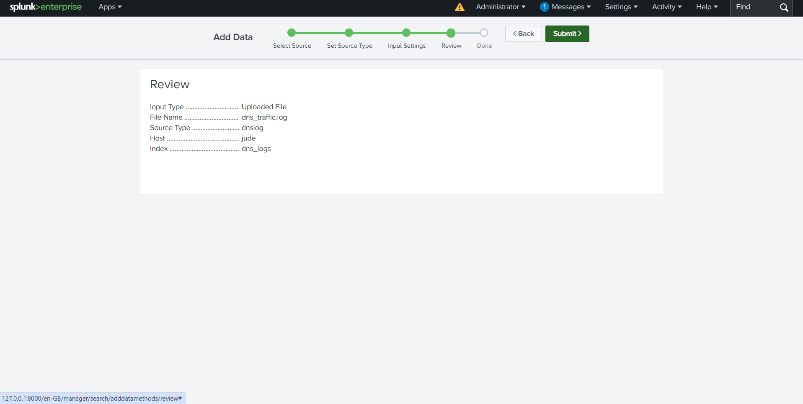

Step 4:

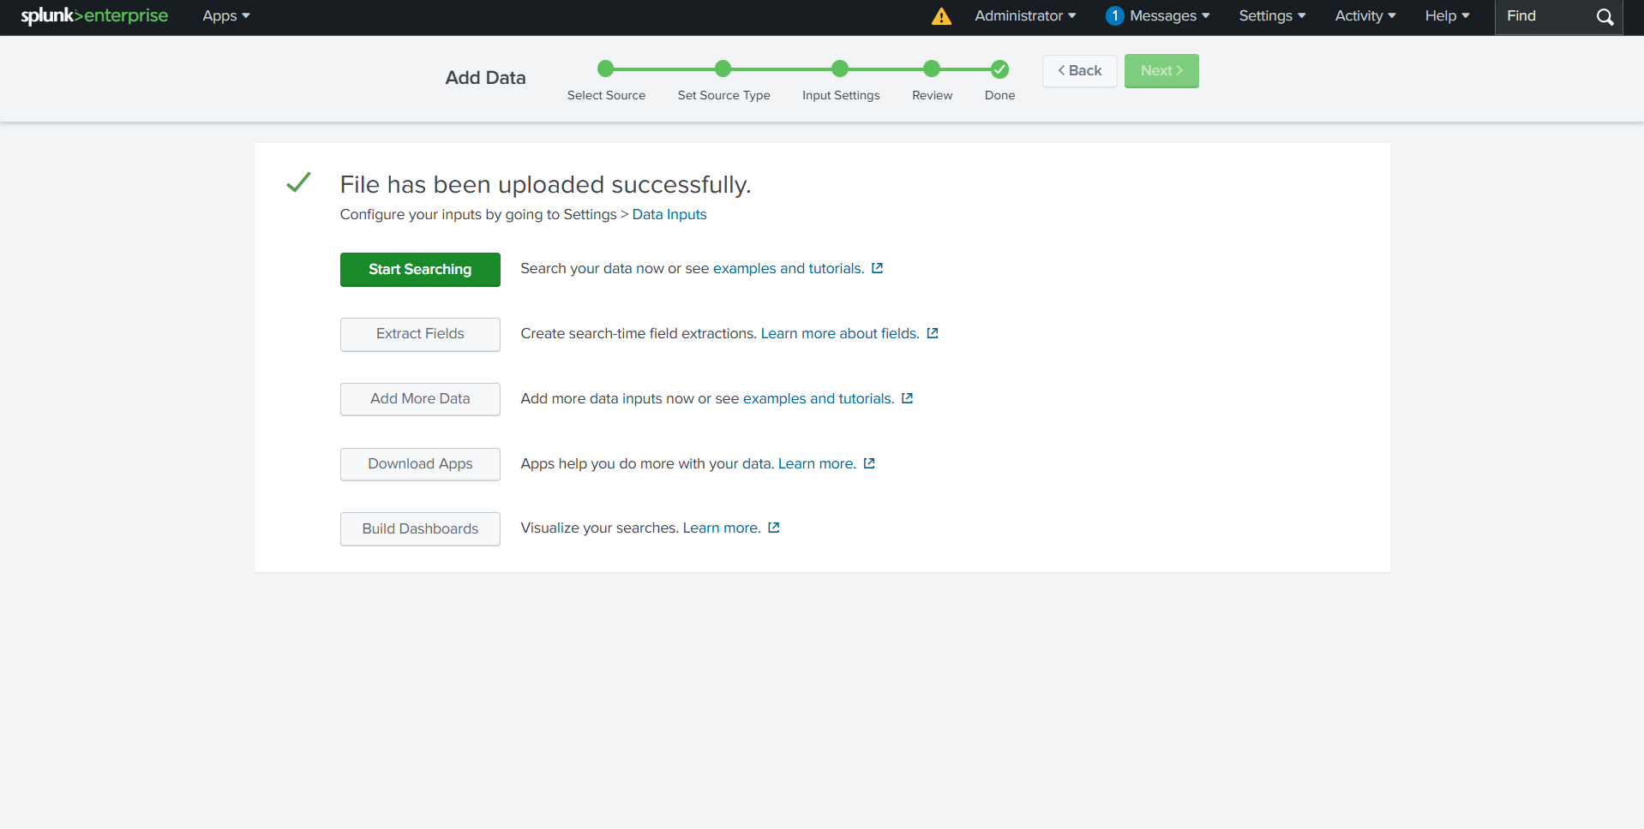

Step 5:

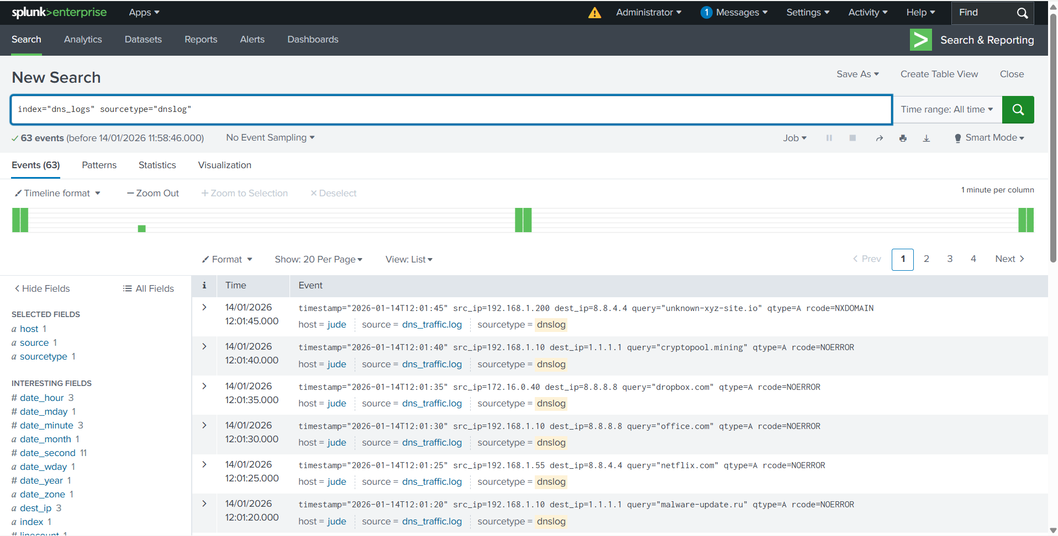

5. Search Queries and Results



.
1)Find queries resulting in "NXDOMAIN" (Non-Existent Domain): This is often a sign of Domain Generation Algorithms (DGA) used by malware.

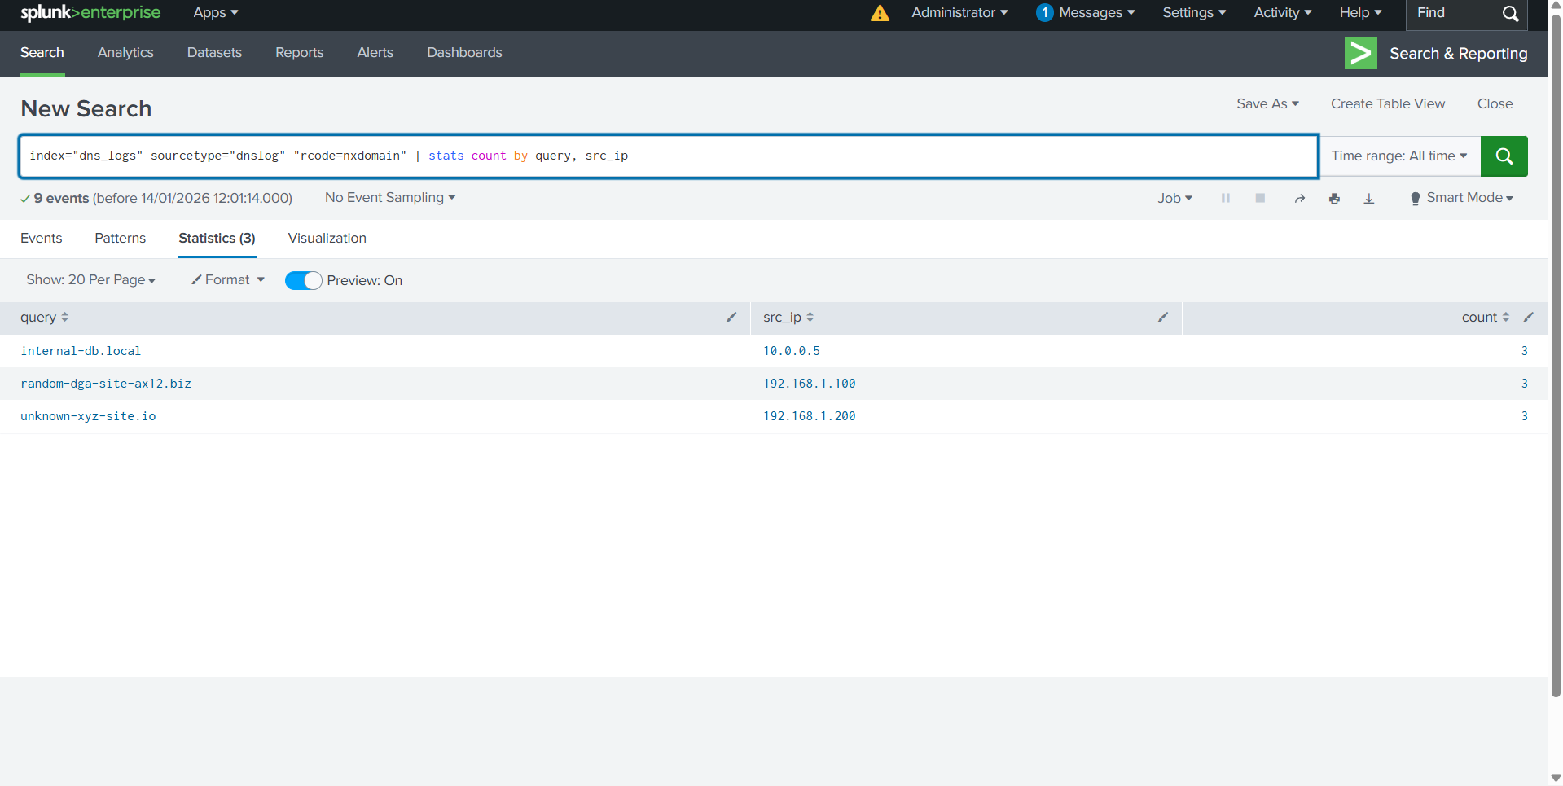
2)Find the most active clients on your network:
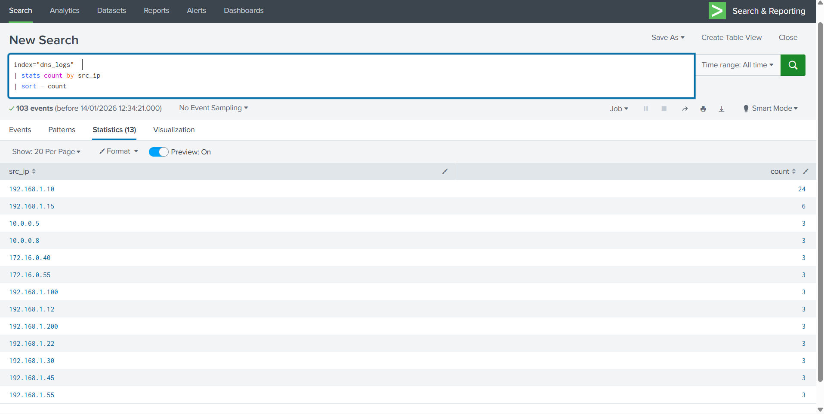
3)Who is talking the most, and where are they going?
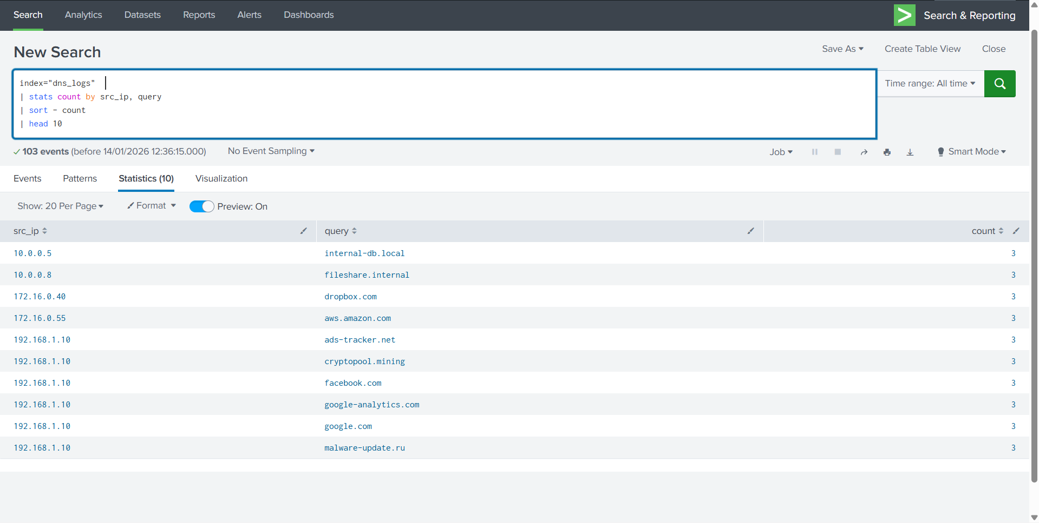

4) Detecting Malware (DGA Check)
Look for NXDOMAIN (Non-Existent Domain). Malware often tries to contact hundreds of "fake" domains. If one IP has many of these, it's likely infected.
( NO SRC_IP IS GREATER THAN 5 THAT WHY NO RESULT)
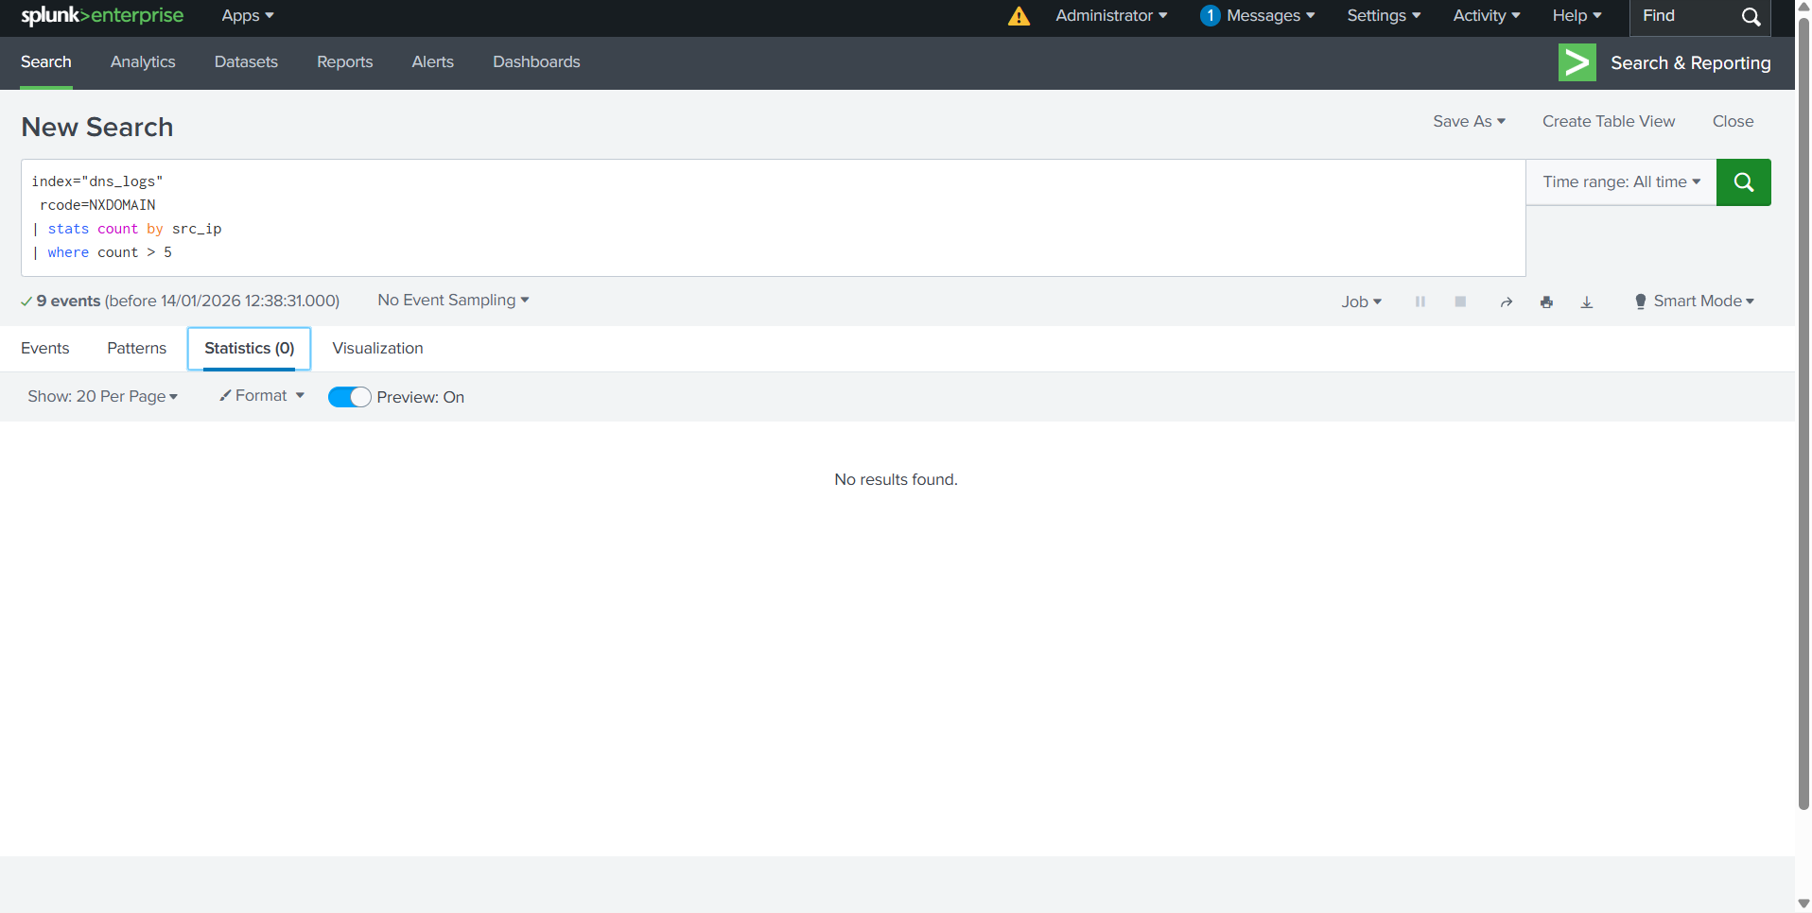
5). Visualizing Traffic Spikes
See when network is most active. Sudden spikes can indicate data exfiltration.

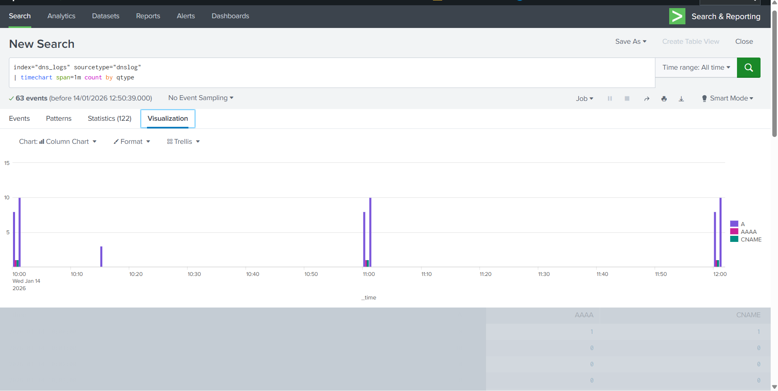

9. Key Learnings
Field Identification: I learned that DNS logs contain critical security fields like qtype (query type) and rcode (response code) which are essential for spotting malicious traffic.
Timechart Visualization: I learned how to use the timechart command to see the "pulse" of network traffic and identify spikes in specific query types like AAAA or CNAME.
Key-Value Parsing: I learned that Splunk can automatically extract fields if they are in key=value format, provided the timestamp is handled correctly first.

